### Grade of the following project will be 15

### Apply this project with any programming language that you prefer it

### The Project will deliver after Eid Elfater direct

### Projects of the Propositional Logic

Translate English to Propositional Logic and apply one of the following:

#### **1) Inference and Decision Making**

**Example:**We can prove that the following premises build up a valid argument using the rule of inference.

“If today is Tuesday, I have a test in English or Science. If my English Professor is absent, then I will not have a test in English. Today is Tuesday and my English Professor is absent. Therefore I have a test in Science.“

T: Today is Tuesday

E: I have a test in English

S: I have a test in Science

A: My English Professor is absent

***Premises as logical notations***

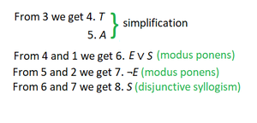

Hence, the argument stated is valid.

***2) Inference rules-based patient diagnosis.***

***3) Inference rules-based system faults and maintenance***